**Excursion Risk Management Plan**

|  |  |  |  |  |  |  |  |  |  |  |  |  |  |  |
| --- | --- | --- | --- | --- | --- | --- | --- | --- | --- | --- | --- | --- | --- | --- |
| Excursion details | | | | | | | | | | | | | | |
| Date(s) of excursion | | | | 10th July 2017 | | | Excursion destination | | | Event Cinemas (Westfield Hornsby) Burdett Street, Hornsby | | | | |
| Departure and arrival times | | | | Leave NWOOSH 9:00am, Return to NWOOSH approx 2:00pm | | | | | | | | | | |
| Proposed activities | | | | Morning Tea, Watch Movie, Lunch | | | | | | Water hazards? Yes/No  If yes, detail in risk assessment below. (Water Clock) | | | | |
| Method of transport, including proposed route | | | | Walk outside OOSH, to side of school onto Milson Parade footpath. Walk along Milson Parade, crossing at Traffic Lights onto Dartford Road until crossing at lights with junction of Pennant Hills Road. Alight on bus, travel along Pennant Hills & Peats Ferry Roads. Disembark at Hornsby Station & Walk across pedestrian footbridge entering Shopping Centre. (Route reverses on return journey.) | | | | | | | | | | |
| Name of RPD | | | | Blake Jervis | | | | | | Contact number of RPD | | | Centre: 9484-4412 (on divert) Mobile:0431-186-403 | |
| Number of educators/parents/volunteers | | | | 2 Educators | | | | | | Zan Diamond, Blake Jervis | | | | |
| Number of children attending excursion | | | | 13 Children | | | | | | Educator to child ratio, including whether this excursion warrants a higher ratio? | | | 1:7 | |
| First Aid Trained Educators (Names): | | | | Zan Diamond, Blake Jervis | | | | | | | | | | |
| Excursion checklist | | | | | | | | | | | | | | |
| □ First aid kits (one per educator) | | | | | | | | □ List of adults participating in the excursion & contact details | | | | | | |
| □ List of children attending the excursion | | | | | | | | □ Phone – Centre phone on divert to RPD mobile phone | | | | | | |
| □ Contact information for each child (hard and soft copies) | | | | | | | | □  Medication for each child with a medication condition | | | | | | |
| □ Medical information for each child downloaded to phone | | | | | | | | □ Excursion T-shirts for each child and educators to wear uniform and name tag | | | | | | |
| □ Walkie Talkies (one for each educator) | | | | | | | | □  Other items, please list: Water, Tissues, backpack, any medication (?) | | | | | | |
| □ Portable Sunscreen | | | | | | | | □ Camera | | | | | | |
| Risk assessment | | | | | | | | | | | | |  | |
| Activity | Hazard identified | Risk assessment  (use matrix) | | Elimination/control measures | | | | | | Who | | When | Residual Risk Rating | |
| Walking to and from Cinemas | * Walking onto road into traffic while walking along and crossing roads.      * Tripping while walking up steps. * Fountain/ Water Clock Hazard * Tripping on new section due to bridgeworks.   (Footbridge crossing) | Extreme  Moderate  Moderate  Moderate | | Supervision will be 1 adult to 9 children. Children will walk in pairs on the left hand side of the footpath.  The educators will position themselves on the road side when walking to the park to keep the children safe.   Educators will stand at the intersection of any road crossing to block oncoming traffic turning into, or out of, the streets. Children will be reminded prior to the excursion to cross only when advised by Educators.  Children will be supervised and guided up and down stairs safely where needed.  Children will be reminded prior to excursion to take the trip up and down any steps slowly and to wait for those in front of them.  Children to be advised to walk around fountain and will be supervised to stay away from fountain edge.  Children supervised and guided to stay to their left while walking across bridge. Children advised to take extra caution walking on new bridge area (temporary metal ramp). | | | | | | Educators and children  Educators  Educators  Educators and children  Educators and children  Educators and children | | Children will be advised to instructions prior to excursion. Educators will position themselves at the beginning of the line, the end of the line and evenly down the middle of the line for the walk to the venue. Educators will remain in this format for entire walk from outside of centre to the school and on the return trip.  During briefing prior to excursion and whilst on the excursion.  During briefing prior to excursion and whilst on the excursion.  During briefing prior to excursion and whilst on the excursion. | Moderate  Low  Low  Low | |
| General | * Lost Child * Sun Burn, Heatstroke, dehydration etc. * Toilet Supervision | Extreme  Extreme    Moderate | | All children will wear excursion T-Shirts whilst on the excursion which have the Centre’s name and phone number.  Educators to wear the service uniform and their name tags at all times  Educators will conduct roll calls and headcounts  UV rating will be checked prior to excursion commencing.  Children and staff will be expected to wear hats at all times. Children will put their hats on before leaving the OOSH building. Children without a hat will be given one from the Centre.  Children will be checked for drink bottles and asked to ensure all are filled prior to the excursion. Any child without water will be given a sealed pre-purchased water bottle by staff before commencement of excursion. Children will be given regular drink breaks throughout the day to ensure they remain hydrated. Water will also be available at the venue.  Educators will ensure shaded play areas and indoor alternatives are available to children.  Sunscreen will be applied to each child, where permission has been given.  Staff are to inspect toilets before use, to check if safe and all-clear before children use them. Children will be notified of the location of the toilets before activity commences. Staff will ensure children go together minimum as pairs, and where practical, in groups of 3. | | | | | | Educators to organise T-Shirts  Educators  Educators  Educators and children  Children- directed by Educators  Educators  Children directed by Educators.  Educators | | Shirts to be worn by each child before departing the OOSH building.  Before departure.  Prior to departing, arrival at the venue, before lunchtime, prior to leaving the venue and on return to the centre. Regular headcounts will also be conducted throughout the day.  Children directed by Educators, Whilst walking to and from venue/transport.  Before departure and reminders throughout the day.  On arrival at the venue.  Before leaving the service. To be reapplied every two hours throughout the day.  On arrival at the venue and then throughout the day before group use by children. | Moderate  Low  Low | |
| Eating & Drinking on Excursion | * Choking whilst drinking and/or eating * Food Allergies | High  Extreme | | Children will be provided space to sit during meal times. They will be reminded to sit whilst drinking and eating.  Children’s allergies will be discussed with educators prior to departure to ensure all educators are aware.  Medication is to be kept with each child throughout the day to ensure prompt access when in different areas of the venue.  Parents to be reminded that the Centre is ‘Nut Aware’ and nuts are not permitted at the service.  Children’s will be asked about their lunches during the excursion to ensure no nuts or any other related allergy products are contained. | | | | | | Educators  Educators  Educators  Educators and Parents  Children, directed by educators | | During excursion  Before departing for the excursion and whilst on excursion.  During Excursion.  During Vacation Care planning process.  During Excursion. | Low  Low  Low  Low  Low | |
| Riding on Bus | * Injury from sudden braking * Alighting onto bus | High  High | | Children will be reminded to sit while travelling on the bus and to face towards the travel of journey  Children reminded to watch the step when alighting onto/from the bus at the stops. Children will also wait in bus shelter away from roadside until bus has arrived at stop when alighting. | | | | | | Educators  Children directed by Educators | | During Excursion  During briefing prior to excursion & whilst on excursion. | Low  Low | |
| Cinema Equipment | * Injury from Seats * Injury from booster seats | Moderate  Moderate | | Educators to inspect seats in cinema before children sit down. Any seats with damage will not be used by children and reported to Cinema Staff. Children will also be advised to ask staff should they find any faults during session.  If required by children, they will be able to use booster seats. Staff will ensure these are securely placed in the seat before child sits down on it. Staff to also remind children to carry seats without swinging as can be dangerous. | | | | | | Educators, children directed by Educators. Cinema staff were applicable.  Educators, children directed by Educators. | | During excursion, prior to use of cinema seat.  During excursion, where applicable, upon entrance of cinema. | Low  Low | |
|  |  |  | |  | | | | | |  | |  |  | |
| **Risk** | | | | | | | | **Benefit** | | | | | | |
| * Injury to tripping or falling due to stairs or bridgeworks * Lost children at venue or during movement to and from the venue * Heat stroke, dehydration, sun stroke etc. * Sharing food with children with allergies * Injury from faulty cinema equipment * Injury on use of public transport (bus) | | | | | | | | * Development of social skills & expected behaviours when with other people of the community * Development of negotiating skills when choosing movie and also choosing seats in cinema * Entertainment through a new movie * Sense of agency through choosing movie * Knowledge of their local area by walking to and from the venue and via bus * FUN! | | | | | | |
| Plan Prepared by: | | | | | | Benjamin Caswell | | | | | | 19th May 2017 | | |
| Plan Reviewed by: | | | | | |  | | | | | | Original: | | |
| Communicated to: | | | | | | To Be Determined | | | | | | | | |
| Venue and safety information reviewed and attached | | | | | | Yes / No  Comment if needed: No further venue information received or required as on OOSH premises | | | | | | | | |
| **Reminder: Monitor the effectiveness of controls and change if necessary. Review the risk assessment if an incident or significant change occurs.** | | | | | | | | | | | | | | |

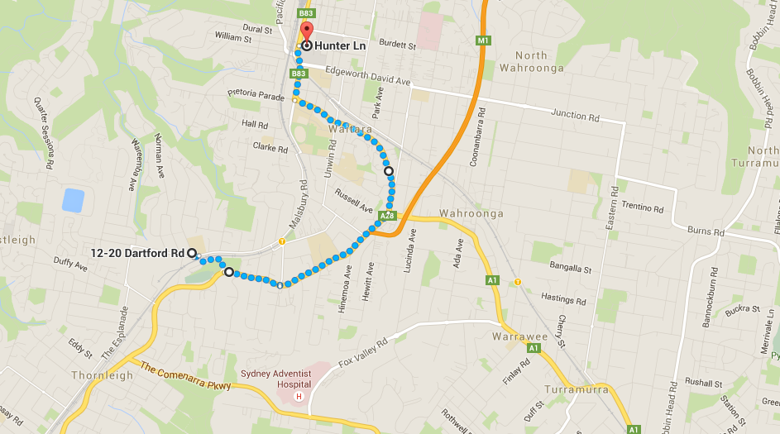

|  |  |  |
| --- | --- | --- |
| Risk Matrix | | |
|  | | **Consequence** |
| **Likelihood** | |  |  |  |  |  |  | | --- | --- | --- | --- | --- | --- | |  | Insignificant | Minor | Moderate | Major | Catastrophic | | Almost certain | Moderate | High | High | Extreme | Extreme | | Likely | Moderate | Moderate | High | Extreme | Extreme | | Possible | Low | Moderate | High | High | Extreme | | Unlikely | Low | Low | Moderate | High | High | | Rare | Low | Low | Low | Moderate | High | | |