**Excursion Risk Management Plan**

|  |  |  |  |  |  |  |  |  |  |  |  |  |  |  |
| --- | --- | --- | --- | --- | --- | --- | --- | --- | --- | --- | --- | --- | --- | --- |
| Excursion details | | | | | | | | | | | | | | |
| Date(s) of excursion | | | | 17th July 2017 | | | Excursion destination | | | Plough & Harrow, Western Sydney Parklands, Elizabeth Drive, Abbotsbury NSW | | | | |
| Departure and arrival times | | | | Leave NWOOSH 9:00am, Return to NWOOSH approx 3:30pm | | | | | | | | | | |
| Proposed activities | | | | Morning Tea, Lunch, Use of Equipment, Games, Relaxation, Free Play | | | | | | Water hazards? Yes/No  If yes, detail in risk assessment below. | | | | |
| Method of transport, including proposed route | | | | Walk outside OOSH, to front of school on Dartford Rd. Catch Chartered Bus from Dartford Road onto Pennant Hills Road, M2, M7, and finally Elizabeth Drive. Use Elizabeth Drive entrance for drop off/pick up inside park near shelter. | | | | | | | | | | |
| Name of RPD | | | | Benjamin Caswell | | | | | | Contact number of RPD | | | Centre: 9484-4412 (on divert) Mobile: 0401-542-328 | |
| Number of educators/parents/volunteers | | | | 5 educators | | | | | | Benjamin Caswell, Roslyn Doyle, Kelcie Sexty, Kaitlin Daoud, Caitlin Shanahan | | | | |
| Number of children attending excursion | | | | 44 Children | | | | | | Educator to child ratio, including whether this excursion warrants a higher ratio? | | | 1:9 | |
| First Aid Trained Educators (Names): | | | | Benjamin Caswell, Roslyn Doyle, Kelcie Sexty, Kaitlin Daoud, Caitlin Shanahan | | | | | | | | | | |
| Excursion checklist | | | | | | | | | | | | | | |
| □ First aid kits (one per educator) | | | | | | | | □ List of adults participating in the excursion & contact details | | | | | | |
| □ List of children attending the excursion | | | | | | | | □ Phone – Centre phone on divert to RPD mobile phone | | | | | | |
| □ Contact information for each child (hard and soft copies) | | | | | | | | □  Medication for each child with a medication condition | | | | | | |
| □ Medical information for each child downloaded to phone | | | | | | | | □ Excursion T-shirts for each child and educators to wear uniform and name tag | | | | | | |
| □ Walkie Talkies or Mobile Phones (one for each educator) | | | | | | | | □  Other items, please list: Water, Tissues, backpack, any medication (?) | | | | | | |
| □ Map of Park (one for each educator) | | | | | | | | □ Sports Equipment For Games and Cones for Boundaries | | | | | | |
| □ Portable Sunscreen | | | | | | | | □ Camera | | | | | | |
| Risk assessment | | | | | | | | | | | | |  | |
| Activity | Hazard identified | Risk assessment  (use matrix) | | Elimination/control measures | | | | | | Who | | When | Residual Risk Rating | |
| Walking to and from bus | * Walking onto road into traffic while walking along and crossing roads.      * Tripping while walking up steps. | Extreme  Moderate | | Supervision will be 1 adult to 9 children. Children will walk in pairs on the left hand side of the footpath.  The educators will position themselves on the road side when walking to the park to keep the children safe.   Educators will stand at the intersection of any road crossing to block oncoming traffic turning into, or out of, the streets. Children will be reminded prior to the excursion to cross only when advised by Educators.  Children will be supervised and guided up and down stairs safely where needed.  Children will be reminded prior to excursion to take the trip up and down any steps slowly and to wait for those in front of them. | | | | | | Educators and children  Educators  Educators  Educators and children | | Children will be advised to instructions prior to excursion. Educators will position themselves at the beginning of the line, the end of the line and evenly down the middle of the line for the walk to the venue. Educators will remain in this format for entire walk from outside of centre to the school and on the return trip.  During briefing prior to excursion and whilst on the excursion. | Moderate  Low | |
| General | * Lost Child * Sun Burn, Heatstroke, dehydration etc. * Toilet Supervision * Serious injuries to a child * Serious injury to a staff member | Extreme  Extreme    Moderate  Moderate  Moderate | | All children will wear excursion T-Shirts whilst on the excursion which have the Centre’s name and phone number.  Educators to wear the service uniform and their name tags at all times  Educators will conduct roll calls and headcounts  UV rating will be checked prior to excursion commencing.  Children and staff will be expected to wear hats at all times. Children will put their hats on before leaving the OOSH building. Children without a hat will be given one from the Centre.  Children will be checked for drink bottles and asked to ensure all are filled prior to the excursion. Any child without water will be given a sealed pre-purchased water bottle by staff before commencement of excursion. Children will be given regular drink breaks throughout the day to ensure they remain hydrated. Water will also be available at the venue.  Educators will ensure shaded play areas and indoor alternatives are available to children.  Sunscreen will be applied to each child, where permission has been given.  Staff are to inspect toilets before use, to check if safe and all-clear before children use them. Children will be notified of the location of the toilets before activity commences. Staff will ensure children go together minimum as pairs, and where practical, in groups of 3.  Where a child has a serious injury, one staff member will render first aid, whilst the others move the other children away and ensure adequate supervision. Where an ambulance is required to be called, the staff member will notify the RPD, and the venue staff who will assist in calling the ambulance. Where a staff member leaving on an ambulance then compromises our child to staff ratio, and the activity is deemed unsafe with the number of remaining educators, the bus driver will be called and the children returned to the centre  Where a staff member has a serious injury, one staff member will render first aid, whilst the others move the children away and ensure adequate supervision. Where an ambulance is required to be called, the staff member will notify the RPD, and the venue staff who will assist in calling the ambulance. Where a staff member leaving on an ambulance then compromises our child to staff ratio, and the activity is deemed unsafe with the number of remaining educators, the bus driver will be called and the children returned to the centre | | | | | | Educators to organise T-Shirts  Educators  Educators  Educators and children  Children- directed by Educators  Educators  Children directed by Educators.  Educators  Children and Educators  Children and Educators | | Shirts to be worn by each child before departing the OOSH building.  Before departure.  Prior to departing, arrival at the venue, before lunchtime, prior to leaving the venue and on return to the centre. Regular headcounts will also be conducted throughout the day. (This includes leaving any area for a new area.)  Children directed by Educators, Whilst walking to and from venue/transport.  Before departure and reminders throughout the day.  On arrival at the venue.  Before leaving the service. To be reapplied every two hours throughout the day.  On arrival at the venue and then throughout the day before group use by children.  During Excursion  During Excursion | Moderate  Low  Low  Low  Low | |
| Eating & Drinking on Excursion | * Choking whilst drinking and/or eating * Food Allergies | High  Extreme | | Children will be provided space to sit during meal times. They will be reminded to sit whilst drinking and eating.  Children’s allergies will be discussed with educators prior to departure to ensure all educators are aware.  Medication is to be kept with each child throughout the day to ensure prompt access when in different areas of the venue.  Parents to be reminded that the Centre is ‘Nut Aware’ and nuts are not permitted at the service.  Children’s will be asked about their morning tea during the excursion to ensure no nuts or any other related allergy products are contained.  Staff will complete an allergy list before the excursion and ensure there are alternate foods for any children with allergies or cultural requirements for the lunch to be provided in the park. | | | | | | Educators  Educators  Educators  Educators and Parents  Children, directed by educators  Educators | | During excursion  Before departing for the excursion and whilst on excursion.  During Excursion.  During Vacation Care planning process.  During Excursion.  Before departing for the excursion and whilst on excursion. | Low  Low  Low  Low  Low  Low | |
| Riding on Bus  Plough & Harrow Park Equipment | * Injury from sudden braking * Alighting onto bus * Bus breakdown * Injury from faulty equipment * Injury (falls) due to misuse of equipment * Injury due to rough play | High  High  Low  High  Extreme  High | | Children will be reminded to sit while travelling on the bus and to face towards the travel of journey  Children reminded to watch the step when alighting onto/from the bus at the stops.  Where a bus breaks down, the children will remain on the bus until another bus is organized, upon which the children will swap busses. Where remaining on the bus is considered dangerous, the RPD will locate a safe area to have the children wait for the new bus to arrive.  Staff to check equipment before use by children.  Any faulty equipment reported to Responsible Person on Duty & children to be notified which equipment is not to be used. (This includes any part of the hired shelter for use.)  Educators to maintain supervision of all children using the equipment. All children to be made aware of potential danger and consequences when equipment is misused.  Educators to inform children that any rough play on the equipment will result in their removal from activities. Educators to maintain supervision of children and pacify any potential conflict. | | | | | | Educators  Children directed by Educators  Educators and children  Educators  Educators, children directed by educators  Educators | | During Excursion  During briefing prior to excursion & whilst on excursion.  During Excursion  During excursion, before commencement of equipment use.  During excursion.  .  During excursion, prior equipment use. | Low  Low  Low  Low  High  Low | |
| Water Hazards at Plough & Harrow | * Water Hazards at Plough & Harrow (Two Ponds) | High | | Children will be directed by staff about water safety before commencement of activities at park. Staff will have maps to identity where the location of the bodies of water are situated. Gaming activities and walks will be kept in parkland and track areas away from water where possible. Staff are to remind children not to enter water, and where necessary, cones will be placed to mark boundaries as a reminder to children. With supervision of activities, where possible, a staff will always be between the children and any bodies of water.  Children will also be advised to stay within boundaries at the lookout walk over the pond, should they elect to walk to that aprt of the park. | | | | | | Educators | | Prior to commencement of activities on the excursion and during the excursion. | Low | |
|  |  |  | |  | | | | | |  | |  |  | |
| **Risk** | | | | | | | | **Benefit** | | | | | | |
| * Lost children at venue or during movement to and from the venue * Heat stroke, dehydration, exhaustion etc. * Asthma attacks due to physical exertion * Sharing food with children with allergies * Injury (sprain, fall, collision) whilst using equipment * Injury from entering water areas | | | | | | | | * Development of social skills & expected behaviours when with other people of the community * Development of physical wellbeing and confidence in abilities * Physical activity and exercise * Development of friendships from other centre on tour * FUN! | | | | | | |
| Plan Prepared by: | | | | | | Benjamin Caswell | | | | | | 19th May 2017 | | |
| Plan Reviewed by: | | | | | |  | | | | | |  | | |
| Communicated to: | | | | | |  | | | | | | | | |
| Venue and safety information reviewed and attached | | | | | | Yes / No  Comment if needed: Venue information booklet to be printed and given to each staff member. This includes a map for all staff of the park. | | | | | | | | |
| **Reminder: Monitor the effectiveness of controls and change if necessary. Review the risk assessment if an incident or significant change occurs.** | | | | | | | | | | | | | | |

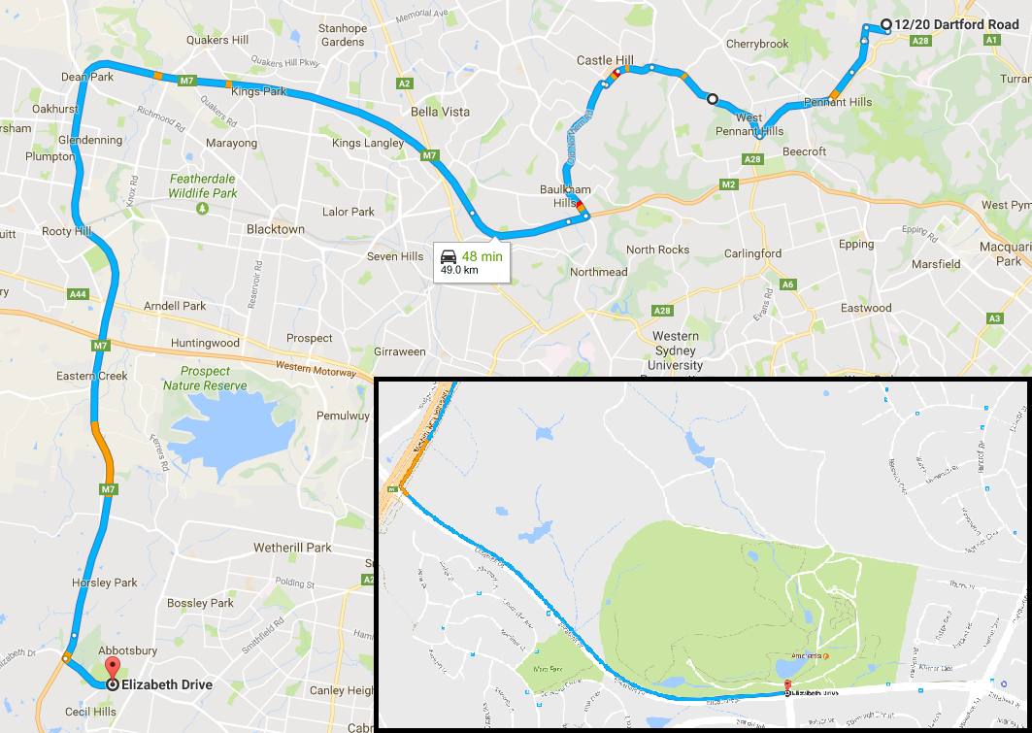

|  |  |  |
| --- | --- | --- |
| Risk Matrix | | |
|  | | **Consequence** |
| **Likelihood** | |  |  |  |  |  |  | | --- | --- | --- | --- | --- | --- | |  | Insignificant | Minor | Moderate | Major | Catastrophic | | Almost certain | Moderate | High | High | Extreme | Extreme | | Likely | Moderate | Moderate | High | Extreme | Extreme | | Possible | Low | Moderate | High | High | Extreme | | Unlikely | Low | Low | Moderate | High | High | | Rare | Low | Low | Low | Moderate | High | | |